Application Information

3D Design classes will each be open to all District 65 Middle School students that will be in 6th, 7th or 8th grade next school year. Student selection for this program will be determined by these application materials and a recommendation from students’ Media Arts teachers, MetaMedia staff, or Evanston Public Library Teen Loft staff.

Applications can be found on the following pages. Please turn in your complete application no later than Monday, June 8th to your Media Arts Teacher or by Monday, June 15th to Mrs. Kushner at kushners@district65.net to be considered for selection into this program.

Students must commit to attending every day of the class they sign up for in its entirety. Check your calendar before applying to ensure that there will not be any conflicts if you are selected.

Where
Classes will be held at the YMCA MetaMedia Lab (1000 Grove Street) on Monday-Thursday each week.

When
Class A will meet August 3rd- 6th from 9:30am - 12pm.
Class B will meet August 10th-13th from 9:30am - 12pm.

Students should only sign up for one class.

How
Students will work with Mrs. Kushner (Chute Media Arts), Ms. Nava (Nichols Media Arts), staff from the YMCA MetaMedia Lab and Renee Neuemeier from the Teen Loft at the Evanston Public Library. This summer program has been generously funded by Foundation 65.

STUDENT APPLICATION

Student Information:

Name_____________________ Grade for 2015-16: _____ School You Attend: ___________

Home Address: ___________________________________________________

Home Phone:_____________________________ Cell No. : _______________________________

Email Address (if you have one): ____________________________

Parent/Guardian Information:

Parent/Guardian Names: ___________________________________________________________

Daytime Phone: _________________________ Cell No. : ____________________________

Email Address:__________________________ Emergency Contact: _______________________

Emergency Contact Cell No. :_______________________
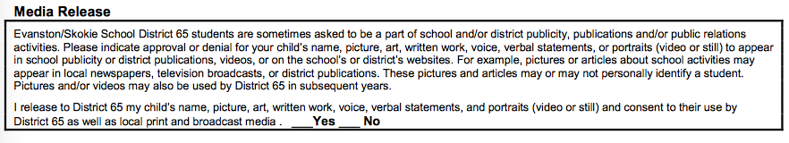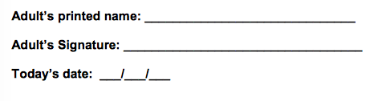

STUDENT ESSAY AND DRAWING
Student First and Last Name: _____________________________________

Circle the class date you are applying for (choose one):

Class A- 3D Design: Monday, August 3 - Thursday, August 6

Class B- 3D Design: Monday, August 10 - Thursday, August 13

Write a one-paragraph statement below explaining why you are interested in this class and what you hope to create:

Draw some sketches that show the 3D design ideas you described above:

STUDENT CONTRACT

I, ______________________, agree to the terms and conditions of the following contract for the Summer Media Arts 3D Design Class. By signing this contract I agree to:

- Attend ALL days of the program, and if I am sick, I will have my parent/guardian contact a teacher in the program
- Actively participate in all aspects of the program
- Be a respectful group member to the teachers and my peers
- Conduct myself in a safe and responsible manner
- Complete all tasks to the best of my ability

I agree to put forth my best effort to complete the items as listed above during this Summer Media Arts 3D Design Class.

Student Signature: _________________________ Date: ___________

